Economics 403B: Project 1

Ross Lewis, Adam Jacobson, David Contento

January 16, 2019

# I

## Introduction

# II

## Results

### 1a

setwd('C:/Users/rossw/Documents/MAE Program/Q2/Applied Econometrics 403B/Project 1')  
data = read.csv("monthly-milk-production-pounds-p.csv")  
names(data) = c('date','milkproduction')  
attach(data)  
datats = ts(milkproduction,start=1962,freq=12)  
datats = na.exclude(datats)  
time = seq(1962,1975,length=length(datats))  
plot.ts(datats)

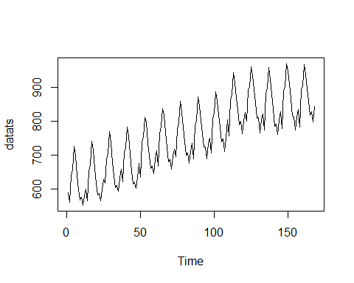

#na.exclude(datats)

### 1b

TODO

### 1c

We observe large amounts of autocorrelation obviously. This shows nonstationary.

#acf and pcf plots  
acf(datats)

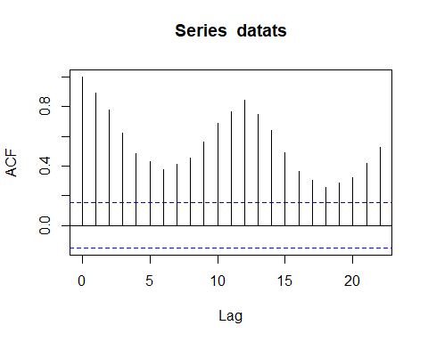

pacf(datats)

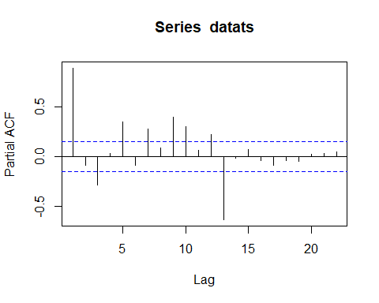

### 1d

#, fig.width=6, fig.height=6  
#Linear Fit  
mod1=lm(datats~time)  
#par(mfrow=c(2,1))  
plot(datats, ylab="Monthly amount of milk production", xlab="Time", lwd=2, col='skyblue3', xlim=c(1962,1975))  
lines(time,mod1$fitted.values,col="red3",lwd=2)

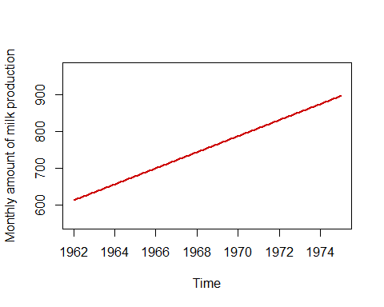

#quadratic fit  
mod2=lm(datats~time+I(time^2))  
#par(mfrow=c(2,1))  
plot(datats,ylab="Monthly amount of milk production", xlab="Time", lwd=2, col='skyblue3', xlim=c(1962,1975))  
lines(time,mod2$fitted.values,col="red3",lwd=2)

